# Construction Phase Status Assessment

## Executive Summary

The construction phase of our project had a few hiccups which resulted in us running behind schedule, these hiccups included:

1. A delay in implementing some features into the application.
2. Changes being made to the application architecture by me (Corie) that were not approved by the rest of the team that caused confusion and frustration amongst the group.

However, we are now in a position where the last remaining application features are now implemented, and there are currently no known bugs with the application. We have a suite of functional acceptance test results that demonstrate this assertion.

We also have beta test materials, which includes a set of use cases we would like our beta testers to complete and feedback forms. Our beta test use cases attempt to have the beta testers interact with all the UI of the application, as well as use all of the features of the application.

Whilst our beta test use cases do not have step by step instructions, we do have a detailed user manual to help our beta testers if they get stuck while testing the application.

We are quite limited by time for the remainder of the project due to the above-mentioned issues we encountered, which means we will have to move quickly to get the initial feedback from our beta testers, so that we will have time to fix any issues identified during the first round of beta testing.

### Key System Qualities and Functionality

Initial requirement analysis identified the following critical and significant system quality and functional requirements:

#### System Qualities

1. The application is easy to use.
2. The application must have a consistent design, such as colour scheme and font style.
3. The application should be stable.
4. The application should respond to user input quickly.
5. The application should have short loading times for data coming from the server.

#### Functional Requirements

1. The user should be able to create either a Google or Anonymous account.
2. The user should be able to add and edit tasks.
3. The user should receive points for successfully completing a task.
4. The user should be able to view a leaderboard of theirs and other users’ achievement while using the application.
5. The application should schedule a notification if the user has entered a due date and time.
6. The application must use encryption on local storage.

The status of key deliverables for the construction phase is that although they’re behind schedule they’re now implemented, tested and complete.

The remaining risk for the project is the following:

|  |  |  |
| --- | --- | --- |
| Issue | Description | Status |
| 1 | Our beta testers may discover a bug in the application, that was not previously identified during alpha testing. | Yellow |
| 2 | Application usability. | Yellow |
| 3 | Application being aesthetically to our beta testers. | Yellow |
| 4 | A breach in the security of the application | Green |
| 5 | Short timeframe to complete the remaining work. | Red |

|  |  |
| --- | --- |
| Key | Description |
| Green | Indicates that the risk is low. |
| Yellow | Indicates that the risk is moderate. |
| Red | Indicates that the risk is significant. |

The remaining risk for the team is the following:

|  |  |  |
| --- | --- | --- |
| Issue | Description | Status |
| 1 | A breakdown in communication amongst the team. | Yellow |
| 2 | IDE compatibility issues within the team | Green |

|  |  |
| --- | --- |
| Key | Description |
| Green | Indicates that the risk is low. |
| Yellow | Indicates that the risk is moderate. |
| Red | Indicates that the risk is significant. |

1. Deliverables
   1. Beta Ready Version of the Product

At the beginning of the project, we had planned to implement the following use cases:

* Create user account.
* The user can add a task.
* The user can view a list of tasks.
* The user can edit a task.
* The user can view task that they have completed previously.
* The task list can be sorted by due date or priority.
* Motivational messages to keep users engaged.
* Notifications for the user when a task is due.
* Scheduled notifications are updated if the task due date and, or due time are edited by the user.

We have been able to implement all the use cases that we had initially planned to at the beginning of the project, the video below demonstrates that the use cases have been implemented.

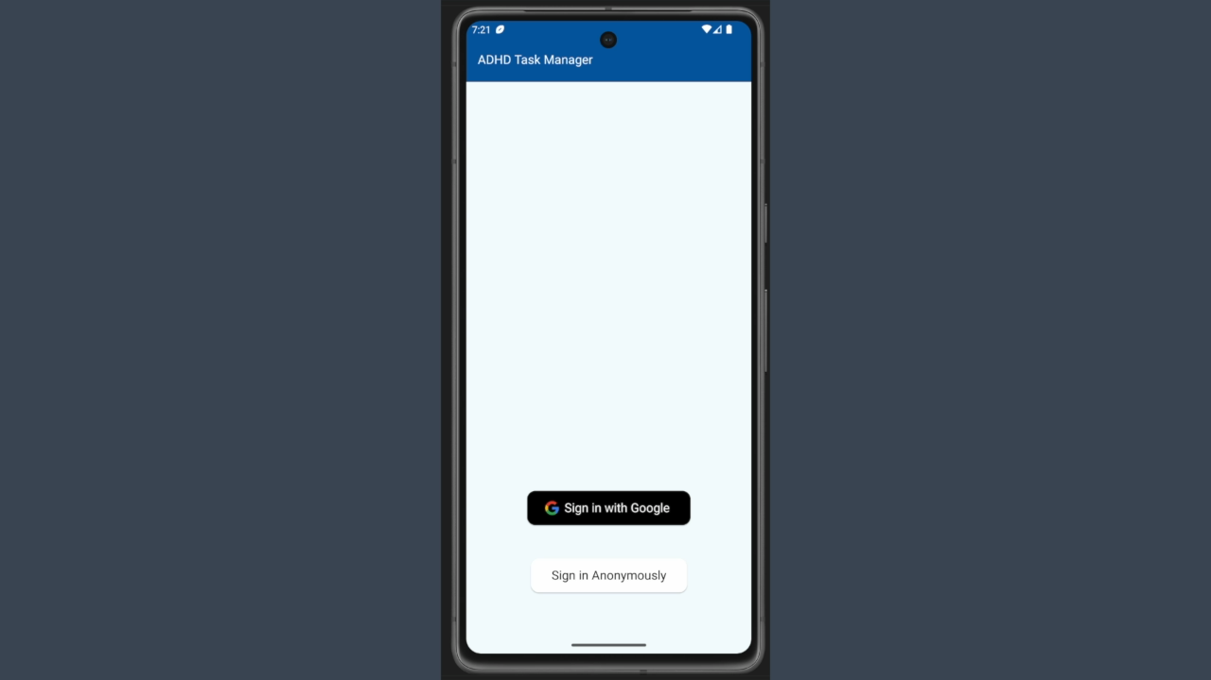The below demo video demonstrates the application going through several use case to show that the application is ready for beta testing.

* 1. Supporting Test Evidence
     1. Functional Acceptance Tests

Our FATs followed a similar script to what we will be asking of our beta tester, however we did have a more detailed look at what the application was doing during each step. The testing document below has all the testing that was completed before we deemed the application to be ready for beta testing:

<https://github.com/commet003/ITC303-9-Team1-Project/raw/testing/IOCM%20Documents/TestingDocument_1_10_23.docx>

* + 1. System Quality Scenarios

All our testing was completed in one document, found here:

<https://github.com/commet003/ITC303-9-Team1-Project/raw/testing/IOCM%20Documents/TestingDocument_1_10_23.docx>

* 1. Beta Test materials

The business scenarios that our beta testers have been asked to complete are the following:

* Create a user account with Google sign in.
* Use the navigation drawer to navigate the application.
* Create a new task.
* Edit a task.
* Delete a task.
* Complete a task.
* Navigate to the Rewards screen to see if they have earned rewards.
* Create a Task with a due date and due time to see if a notification is generated to remind them of the task.
* Navigate to the Leaderboard screen to see their position on the leaderboard.
* Navigate to the Settings screen.
* Toggle Dark / Light mode.
* Update their display name.
* Update their country.
* Update their profile picture.
* Change the pomodoro timer work time to 2 minutes.
* Change the pomodoro timer break time to 1 minute.
* Whilst the pomodoro timer is active, use the pause, resume and stop buttons.
* Sign out of their account.
* Sign back into their account.

We have decided on these because we feel that they cover all the functionality of the application and will help our beta tester uncover any potential bugs, and to help them give us feedback on all functionality of the application. This will help our beta tester provide feedback on what needs to improve to improve the quality of the application.

Beta Tester Instructions:

<https://github.com/commet003/ITC303-9-Team1-Project/raw/testing/Beta%20Testing%20Instructions/Beta%20Testing%20Instruction%20and%20Feedback%20Document.docx>

Beta Tester Feedback Form:

<https://forms.gle/hJqwGA2noRdWfynU8>

* 1. User Manual

The User Manual is available to our beta testers in the application, to make it easy for them to find if they need. We also have a copy in our GitHub repo which is linked below.

<https://github.com/commet003/ITC303-9-Team1-Project/blob/testing/ADHDTaskManagerApp/app/src/main/assets/UserManual.md>

1. Iterations
   1. Construction Iteration 1

Are key objectives for this iteration was to complete the following:

1. Finish the pomodoro timer.
2. Finish user authentication.
3. Develop Firebase Firestore table to store user tasks.
4. Develop all the logic for the settings screen.
5. Develop the Help screen page.
6. Develop the user profile view.
7. Complete the Rewards screen.
8. Test all the completed work for this iteration and record results.

One of our objectives for this iteration was abandoned, we decided not to go ahead with developing the Firebase Firestore table to store user tasks.

Of our remaining objectives we were not able to complete the development of the pomodoro timer, develop the user profile screen or finish the development of the Rewards screen, with all of those objectives being pushed to Construction Iteration 2. All our team members encountered delays in their respective work items due to previously unforeseen technical issues of challenges in implementing the work item.

* 1. Construction Iteration 2

Are key objectives for this iteration was to complete the following:

1. Implement “Feel Good” Statements.
2. Develop the Leaderboard screen view.
3. Develop the Leaderboard screen logic.
4. Develop functionality to set the device to Do Not Disturb when the pomodoro timer’s current phase is set to work time.
5. Review the user interface of the application for ease of use.
6. Make changes to the UI based on the results of the review.
7. Test all work items for this iteration and record results.

These work items were in addition to the two work items being carried over from C-1, those being the development of the pomodoro timer and completing the development of the Rewards screen.

Overall, the team got bogged down in work items and finished the iteration acknowledging that we had bitten off more than we could chew. Most of our work items had taken significantly longer than the amount of time that we had allocated for them, resulting in a lot of work items being partially completed or not started.

* 1. Construction Iteration 3

Are key objectives for this iteration was to complete the following:

1. Use mobile security framework to analyse the application for security flaws.
2. Fix any security flaws that were discovered during analysis.
3. Tidy the Leaderboard screen.
4. Finish developing the application settings logic.
5. Finish the development of the rewards system.
6. Tidy up the Rewards screen.
7. Develop the User Profile Screen.
8. Test all the work completed during this iteration and record the results.

We were able to get quite a bit of work done during in this iteration, however, due to the delay in finishing our work items we ran out of time to test all the work we had completed during this iteration.

We ended up carrying several work items over to C-4, including, the development of the logic for the application settings, fixing the security issues discovered during the analysis and the final part of the development of the rewards system. We also had known bugs at the conclusion of the development of the user profile screen, and some changes to make to the rewards screen based on feedback of the team.

* 1. Construction Iteration 4

Are key objectives for this iteration was to complete the following:

1. Fix any security flaws found during the analysis.
2. Test the functional accuracy of the rewards system.
3. Finish developing the rewards system.
4. Finish tidying up the Rewards screen.
5. Finish the development of the user profile screen.
6. Test all the work that was completed during this iteration and record the results.

During this iteration the team decided to abandon the user profile page because the rewards screen already contained the user’s information on it.

The team was able to get a lot of outstanding work items completed in addition to the scheduled work items for this iteration. However, we still had an issue with the rewards system accurately keeping track of when the user last logged in, and if they needed to be awarded points for their first log in of the day or if they had already been awarded points for today. At the conclusion of this iteration, we also had to conduct more checks to ensure that the fixes for the security flaws we found were working as intended and did not introduce any new bugs or flaws.

* 1. Construction Iteration 5

Are key objectives for this iteration was to complete the following:

1. Complete the User Manual.
2. Complete the test models.
3. Complete the Construction Phase project assessment.

Unfortunately, during this iteration, we had a major breakdown in communication and best practices in the team, which resulted in this iteration being essentially a write off. The issue was that I (Corie) made quite significant changes to the testing branch of the application without staging the changes and waiting for feedback from the rest of the team, and without communicating to the rest of the team about the changes I was working on.

We were, however, able to recover from this set back, and restore the team’s communication and set the practice of holding pull request and merges into the testing branch until the rest of the team can review and approve the changes that have been made.

* 1. Construction Iteration 6

Are key objectives for this iteration was to complete the following:

1. Fix bugs in the application.
2. Complete the user manual.
3. Complete the test model.
4. Complete the Construction Phase project assessment.

We have spent this iteration recovering from the last iteration, the changes that were made to the testing branch in the last iteration were reverted, and the team has worked together to complete the remaining work items and get the application ready for beta testing.

1. General Issues
   1. General Issue 1 – Team Communication

Team communication has been a consistent issue for our team since the beginning of the project. While all members of the team have put effort into improving this issue, it has continually been an issue with the team and the project. We have tried several things to remedy this issue, including tagging team members directly in Discord that you need to communicate with, to ensure that they are notified of the message. While we have improved the speed of responses from team mates the quality of the communication has remained an issue.

* 1. General Issue 2 – Structured Processes for Merging Completed Work

The lack of structured processes for team members to merge work items that they have completed during an iteration contributed to the issues the team experienced during iteration C-5.